**CHAPTER 1**

**OBJECTIVE**

**Spreading Public Awareness for Positive Change**

Raising public awareness is essential for tackling significant issues and encouraging meaningful change. Engaging in open conversations, sharing accurate information, and utilizing social media platforms allow us to reach a larger audience and encourage collective efforts. Gaining knowledge and educating others on important topics enable individuals to make informed choices and collaborate towards building a more aware, compassionate, and sustainable society.

To effectively spread awareness, a variety of activities can be implemented. Hosting educational workshops, seminars, and webinars can provide valuable insights and engage the public on key issues. Distributing brochures, flyers, and posters helps convey important messages to a wider audience. Organizing community gatherings, rallies, and awareness campaigns fosters public engagement and participation.

In this initiative, awareness was raised through direct action rather than simply advising or encouraging others. By actively engaging in cleanup efforts, a visible example was set for the community, demonstrating that anyone can take the initiative to improve their surroundings and contribute to a healthier environment.

**Importance of a Clean Society**

Maintaining cleanliness in our surroundings is vital for several reasons. A clean environment enhances public health by reducing the spread of diseases and improving overall well-being. Additionally, it contributes to a more pleasant and visually appealing community, making residential and public spaces more enjoyable for both residents and visitors. A well-maintained environment also fosters a sense of responsibility and pride, encouraging individuals to take an active role in preserving their surroundings.

By participating in cleanliness initiatives and promoting hygiene, individuals can effectively spread awareness in various ways. Setting an example through action inspires others to adopt responsible waste management practices. Such efforts also encourage discussions about environmental conservation, highlighting the impact of pollution and litter on ecosystems. Through continuous community involvement, a cleaner and healthier environment can be achieved for present and future generations.

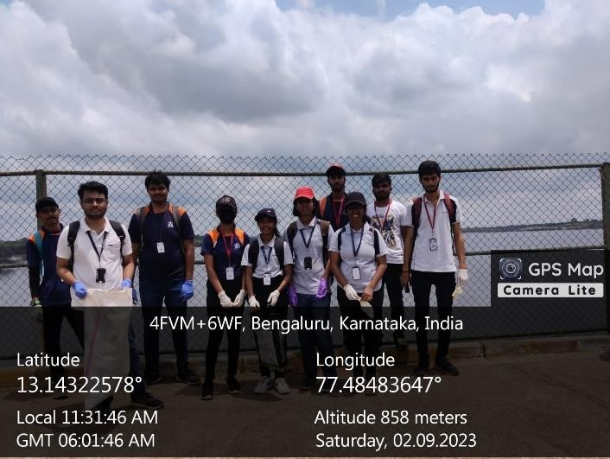

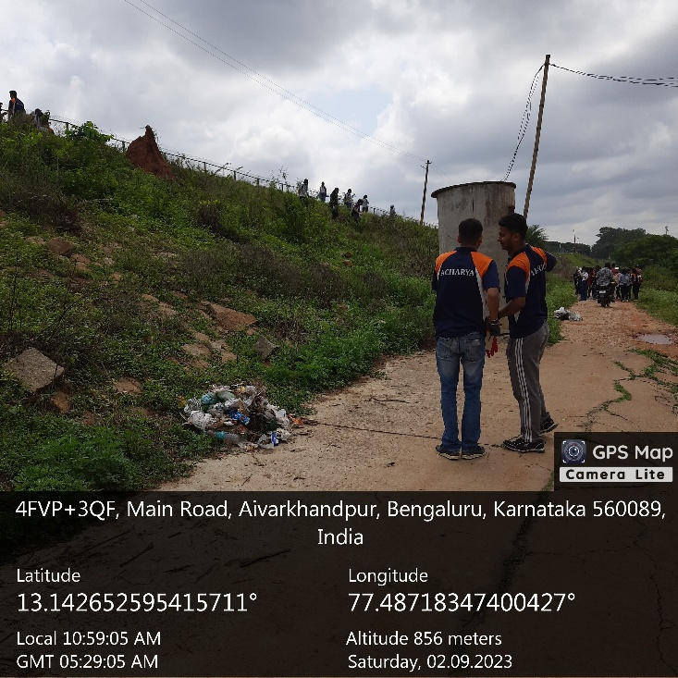

**CHAPTER 2**

**ABOUT THE PLACE**

Hesaraghatta Lake is a man-made reservoir located in the state of Karnataka, India, on the northwestern outskirts of Bangalore, approximately 20 kilometers from the city center. The lake has been a significant water body for Bangalore, originally serving as a primary drinking water source and an irrigation facility for the surrounding agricultural regions. Over time, the lake has transformed into an important ecological and recreational hub, attracting nature lovers, ornithologists, and conservationists.

Despite its historical importance and rich biodiversity, Hesaraghatta Lake faces numerous environmental threats such as water pollution, encroachment, and decreasing water levels due to rapid urbanization. Conservation efforts are being made to restore its ecological balance and preserve its status as a natural and cultural landmark in Bangalore.

Hesaraghatta Lake was built in 1894 as part of the Chamarajendra Water Works project under British rule. The lake was originally designed to supply drinking water to Bangalore, a rapidly growing city that faced water shortages due to its location on an elevated plateau.

The lake was fed by the Arkavathi River, which ensured a steady water supply for both drinking and agricultural purposes. Over the years, Hesaraghatta became an essential part of Bangalore’s water management system, playing a vital role in maintaining the city’s water security before the advent of modern pipeline networks and reservoirs like the Cauvery water supply system.

Although Hesaraghatta Lake is no longer the primary source of drinking water, its historical importance remains significant. The lake stands as a reminder of Bangalore’s early urban planning efforts, showcasing how past generations tackled water management challenges.

Hesaraghatta Lake is **not just a water reservoir**—it is a **thriving ecosystem** that supports a wide range of flora and fauna. The lake and its **surrounding wetlands** provide an essential habitat for **migratory birds, aquatic species, and local wildlife**.

**Key Ecological Features:**

* Birdwatching Haven – The lake attracts over 200 species of birds, including herons, egrets, pelicans, kingfishers, and cormorants. During migration seasons, rare species arrive, making the lake a hotspot for ornithologists and nature photographers.
* Wetland Ecosystem – The marshy and grassy areas around the lake serve as breeding grounds for birds, small mammals, and aquatic species. These wetlands also play a vital role in filtering pollutants and maintaining the lake’s ecological balance.
* Flora and Fauna – The region around Hesaraghatta consists of grasslands, shrubs, and aquatic vegetation, supporting a wide variety of wildlife, including frogs, butterflies, and reptiles.
* Groundwater Recharge – The lake plays a crucial role in replenishing the groundwater levels in the surrounding areas, contributing to sustainable water management.
* The rich biodiversity of Hesaraghatta Lake makes it a valuable ecological zone that requires careful preservation.

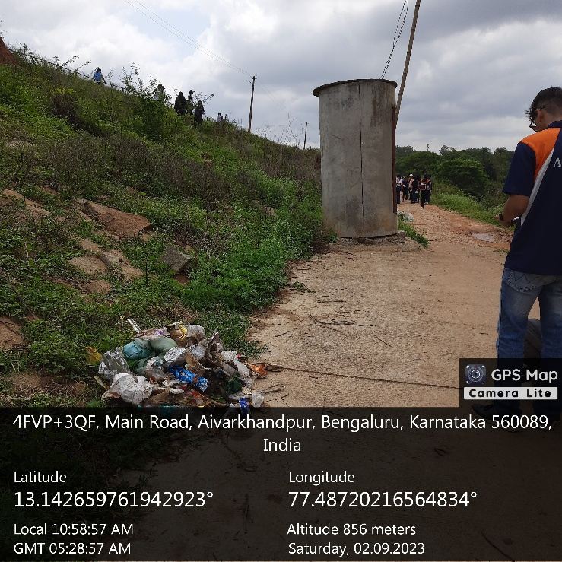

**CHAPTER 3**

**ACTION PLAN**

|  |  |  |  |  |
| --- | --- | --- | --- | --- |
| **SLNO** | **DATE** | **ACTIVITY** | **DURATION** | **REMARKS** |
| 01 | 02-09-2023 | Visiting places and Enquiring | 3 | Visited Places And Enquired about places |
| 02 | 03-09-2023 | Cleaning Roads | 7 | Cleaned Roads |
| 03 | 03-09-2023 | Cleaning Roads | 7 | Cleaned Roads |
| 04 | 03-09-2023 | Promote Cleanliness | 7 | Promoted Cleanliness |
| 05 | 03-09-2023 | Promote Cleanliness | 7 | Promoted Cleanliness |
| 06 | 05-09-2023 | Collecting wastes | 7 | Collected Wastes |
| 07 | 05-09-2023 | Collecting wastes | 7 | Collected Wastes |
| 08 | 05-09-2023 | Collecting wastes | 7 | Collected Wastes |
| 09 | 08-09-2023 | Cleaning Public Places | 7 | Cleaned Bus stops |
| 10 | 08-09-2023 | Cleaning Public Places | 7 | Cleaned Bus stops |
| 11 | 08-09-2023 | Cleaning Public Places | 7 | Cleaned Public places |
| 12 | 10-09-2023 | Gathering geo tag photos and making detailed report | 3 | Made a detailed Report |

**CHAPTER 4**

**CONDUCTION OF THE ACTIVITY**

Taking part in this environmental initiative was a rewarding experience, allowing us as students to contribute meaningfully to the conservation of nature. Hesaraghatta Lake, a well-known public attraction, has been facing increasing pollution and waste accumulation due to frequent human activities. As one of Bangalore’s historically and ecologically significant water bodies, it has suffered from continuous littering, neglect, and lack of proper waste disposal mechanisms. The accumulation of plastic, food waste, and other non-biodegradable materials has severely affected both the land and water ecosystems, posing a threat to local wildlife and biodiversity.

Recognizing the urgency of the situation, our team undertook a clean-up initiative to restore and safeguard the lake’s surroundings. This activity was not just an act of service but also a learning experience that emphasized the importance of community involvement in environmental preservation. Through teamwork, careful planning, and active participation, we were able to make a visible impact on the area.

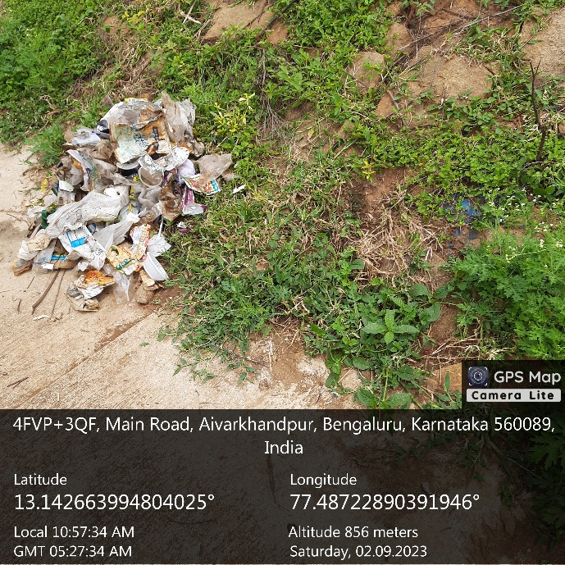

**Organizing the Clean-Up Drive**

The cleanup was conducted through systematic planning and execution. Before beginning, participants were divided into several teams, each assigned to specific zones around the lake to ensure that all areas were covered efficiently. The teams included:

* Waste Collection Team – Focused on picking up plastic, paper waste, and non-biodegradable materials.
* Water Cleanup Team – Removed floating waste and pollutants near the lake’s shore.
* Sorting & Disposal Team – Separated collected waste into recyclable and non-recyclable categories for proper disposal.
* Supervision & Safety Team – Ensured that all participants followed safety measures and guidelines.

Precautionary measures were strictly followed throughout the activity, with faculty and organizers overseeing the event to ensure proper waste disposal techniques and participant safety. All students were provided with gloves, garbage bags, and cleaning tools to facilitate the process.

The teams worked diligently to remove waste that had accumulated over time. Plastic bottles, wrappers, food containers, and other pollutants were cleared from walking trails, picnic areas, and the lake’s edges. It was alarming to see the extent of pollution, but it also reinforced the need for more such initiatives to maintain public spaces in their natural, unpolluted state.

**Impact & Key Learnings**

This activity served as a practical lesson on the importance of environmental responsibility. While the clean-up effort lasted only a few hours, its impact was substantial—not only in improving the lake’s condition but also in raising awareness among visitors and the local community.

**Positive Outcomes:**

* Immediate Improvement in Cleanliness – The removal of waste significantly improved the aesthetic appeal and hygiene of the area.
* Increased Awareness Among Visitors – Many passersby showed interest in our efforts, realizing the importance of responsible waste disposal.
* Reinforcement of Environmental Values – The experience reinforced the idea that small efforts collectively make a big difference in environmental conservation.
* Encouraging Sustainable Habits – Participants learned the importance of reducing plastic usage, recycling, and encouraging eco-friendly habits.

It was evident that keeping public places clean is not solely the responsibility of authorities but also of every individual who uses these spaces. Through this activity, we realized that cleaning is just one part of the solution—the real challenge is to prevent pollution in the first place.

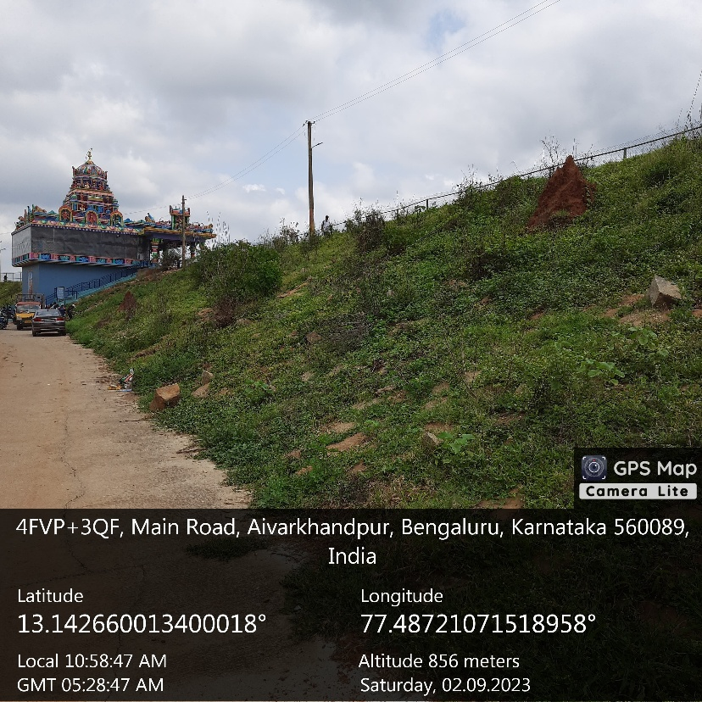

**CONCLUSION**

As natural resources are finite and essential for future generations, their effective management has become a global concern. Ensuring that resources remain available for future use requires the adoption of efficient waste management strategies across different waste types, including medical, household, and industrial waste. This study aims to assess public awareness regarding waste management by analyzing people’s understanding, attitudes, and behaviors towards proper waste disposal and its environmental impact.

**Research Approach**

The study utilizes survey-based research to evaluate knowledge and awareness levels regarding waste management. The survey includes questions focusing on waste disposal practices, environmental awareness, and public behavior. The participants in the study were pharmacy students receiving laboratory training in the healthcare field, providing insights into how individuals involved in scientific and medical disciplines perceive waste management.

To ensure the reliability and consistency of the questionnaire, internal consistency reliability tests were applied. Additionally, statistical methods such as Pearson correlation, t-tests, and ANOVA (Analysis of Variance) were used to analyze differences in awareness and behavior among various groups based on demographics, educational background, and environmental organization membership.

The study highlights that educational background, gender, and environmental engagement significantly influence waste management awareness and behavior. It also emphasizes the need for greater public education programs, policies, and awareness campaigns to further improve waste management practices. Encouraging active participation in environmental organizations and incorporating waste management training into educational curricula can lead to more sustainable behaviors and improved waste disposal practices.

Ultimately, this research reinforces the idea that raising public awareness and promoting responsible waste management are key to protecting the environment and ensuring the sustainable use of natural resources for future generations.